

**Jesus Calls Disciples**

**Mark 1:16-20; John 1:35-51**

**Church Announcements**

* [Type your content here]

Jesus calls four fishermen to follow him. They immediately leave their nets to follow him. Jesus also calls Philip, who recruits his friend Nathanael. Nathanael is impressed by Jesus’ knowledge of him. Jesus changes all of these men’s lives, and Jesus can change our lives, too.

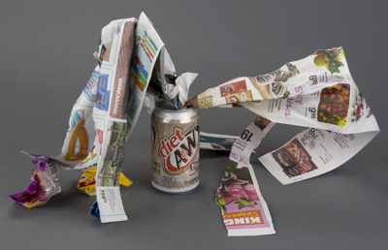

**A New Creation**

Repurpose trash to show how Jesus can make us new.

1. Go through your trash and recycling to find clean trash items. No banana peels or dirty tissues!
2. Grab some tape, glue, and scissors.
3. Make new creations out of the old trash.
4. Read together 2 Corinthians 5:17.
5. Show off your new creations and talk about:
   * **How did you think of ways to use old things in a new way?**
   * **What are some ways Jesus makes us new?**

**Family Discussion**

* What’s exciting to you about change?
* What’s scary to you about change?
* What do you think Jesus might want to change in your life?

**Through the Week**

Here’s an activity you can do throughout the week.

1. To start, cut out 1-inch squares of paper in different colors, and arrange them like pixels to create artwork. Tape the pixels onto a wall or fridge by rolling up tape on the back.
2. Throughout the week, family members can rearrange the pixels to make new art.
3. At the end of the week, talk about what you saw, using these questions.
   * **What are some changes you noticed in our art throughout the week?**
   * **What are some changes you made?**
   * **Which changes were your favorite?**
   * **What are some things you’ve seen Jesus change about you?**



*“This means that anyone who belongs to Christ has become a new person. The old life is gone; a new life has begun!” (2 Corinthians 5:17).*